Artificial Intelligence
The University of Toledo
(College of Engineering)
(EECS 4740/5740)

Instructor: Ashish Kharel  Email: Ashish.Kharel@utoledo.edu  Office Hours: T,TR: 2:15PM to 4:00PM  Office Location: NI 2022  Office Phone: (419) 530-8153  Term: Fall 2026  Course Website: Blackboard Learn | Class Location: NE2109  Class Day/Time: TTR, 12.55 pm–2.15 pm  Lab Location: None Day/Time: None  Credit Hours: 3

Assignment 3: Adversarial Search — Minimax, Alpha-Beta Pruning, and a Tic-Tac-Toe Agent (80 points)
Academic Integrity & AI Policy (The "Dumbbell vs. Forklift" Protocol)
In this course, AI tools must function like a dumbbell (building your cognitive capability through deliberate effort), not a forklift (doing the work for you while your skills remain stagnant).
- Prohibited: Copy-pasting problem statements into Large Language Models (LLMs) like ChatGPT, Claude, or Gemini to generate solutions, or submitting text/code written by an AI.
- Permitted: Using AI as a tutoring partner to clarify general background concepts, explain syntax errors, or generate supplementary practice drills.

Part 1: Warm-Up by Hand — Flipping the Root (18 Points)
Reuse the exact game tree from Lecture 6 (slide name: A small tree, computed bottom-up). The root has three children — call them Branch A, Branch B, and Branch C — and each branch has three leaf values, read left to right:
Branch | Leaf 1 | Leaf 2 | Leaf 3
A | 3 | 12 | 8
B | 2 | 4 | 6
C | 14 | 5 | 2

In lecture, the root was a MAX node and each branch (A, B, C) was a MIN node, giving a final value of 3 through Branch A. For this assignment, make the root a MIN node instead — which makes each branch a MAX node.

Question 1.1: Minimax with MIN as the Root (8 Points)
Compute the minimax value of this MIN-rooted tree. Show your work: first compute the value at each of the three branch nodes (now MAX nodes), then compute the value at the root (now MIN). State the final value and which branch it comes through.

Question 1.2: Recursion Is Still a Stack (3 Points)
Plain minimax (no pruning) always visits every leaf, so a recursive, depth-first minimax function explores this tree strictly left to right: it dives all the way into Branch A's leaves before it ever looks at Branch B, and all the way into Branch B before Branch C. List the order in which all 9 leaves are visited.
3,12,8,2,4,6,14,5,2
Question 1.3: Alpha-Beta Pruning on the Flipped Tree (7 Points)
Now trace alpha-beta pruning on this same MIN-rooted tree, searching left to right (Branch A first, then B, then C; within a branch, leaves left to right). At each branch, report the alpha/beta values as they are carried in and state whether any leaves are skipped. How many of the 9 leaves does alpha-beta actually visit? Does the final value match Question 1.1?

Part 2: Building the Tic-Tac-Toe Environment (15 Points)
Lecture 6 wrote games down as five formal pieces: S₀, TO-MOVE(s), ACTIONS(s), RESULT(s,a), and IS-TERMINAL(s) / UTILITY(s,p). This part asks you to implement exactly those five pieces for tic-tac-toe in Python, using the board mapping from the lecture example.
State representation: a tuple of 9 entries, each 'X', 'O', or None, laid out as:
0 | 1 | 2
3 | 4 | 5
6 | 7 | 8

You are given WIN_LINES (the eight ways to get three in a row) and a working winner(state) function that uses it. Complete the five functions below (both here, and in the provided .py file) . Do not change any function's name or parameters.
def to_move(state):
"""
TODO: Whose turn is it?
X always moves first. Count how many X's and O's are on the board
to figure out whose turn it is now.
Return either 'X' or 'O'.
"""
xCount=state.count ('X')
oCount=state.count ('O')

return 'X' if xCount==oCount else 'O'

def actions(state):
"""
TODO: Return a list of the legal moves in `state`.
A move is just the index (0-8) of an empty cell.
"""
return [i for i in range(9) if state[i] is None]

def result(state, a):
"""
TODO: Return the state that results from the player-to-move playing
cell `a`. Do NOT modify `state` itself -- build and return a new tuple.
"""
board=list(state)
board[a]=to_move(state)
return tuple(board)

def is_terminal(state):
"""
TODO: Return True if the game is over: either someone has won
(use the `winner` function above), or the board is completely full.
"""
return winner(state) is not None or all (cell is not None for cell in state)
# only win the game when x or o is returned and not none

def utility(state, player='X'):
"""
TODO: Only called on terminal states. Return:
+1 if `player` has won
-1 if the opponent has won
0 for a draw
"""
w = winner(state)
if w is None:
return 0
return 1 if w == player else -1

#1 point for player and -1 for opp
Question 2.1: Complete the Five Functions (12 Points)
Fill in to_move, actions, result, is_terminal, and utility above. Test your work with a few boards by hand before moving on — an empty board should say it's X's turn, and a full board with no winner should be terminal with utility 0.
Question 2.2: What's Actually New Here? (3 Points)
In 2–3 sentences: which of these five functions plays the same role as Chapter 3's transition model? Which piece is genuinely new compared to a single-agent search problem, and why did single-agent search never need it?
The result function plays the same role as the transition model. The To-move function is new compared to a single agent search problem and this is because the single-agent model never had to decide when it was his turn or someone else’s; it was the only one choosing its actions so didn’t need a turn.

Part 3: Implementing Minimax (35 Points)
Now implement the real algorithm from Lecture 6 on your own environment — this is the heart of the assignment. Test boards for this part (index positions use the layout from Part 2):
board_a = ('X', 'X', None, 'O', 'O', None, None, None, None) # X can win now
board_b = ('X', None, None, 'O', 'O', None, None, None, 'X') # X must block O

Complete minimax_value below. minimax_decision is already written for you and calls it.
# ---------------------------------------------------------------------
minimax_nodes_visited = 0

def minimax_value(state):
#+1 = X wins,wants MAX 0=draw, -1= O wins, wants MIN
"""
TODO: Recursively compute the minimax value of `state`, from X's
perspective (i.e. always call utility(state, 'X') at terminal states).

Three cases, exactly as in Lecture 6:
1. If state is terminal, return its utility.
2. If it's X's move, return the MAX of minimax_value over all children.
3. If it's O's move, return the MIN of minimax_value over all children.

A "child" is result(state, a) for each a in actions(state).
"""
global minimax_nodes_visited
minimax_nodes_visited += 1

#Case 1: game ends/terminal state= return its utility

if is_terminal(state):
return utility(state, 'X')

#Case 2: X's turn, return the minimax value over all children
if to_move(state)== 'X':
return max(minimax_value(result(state, a)) for a in actions(state))

#Case 3: O's turn, return the minimax_value over all children
return min(minimax_value(result(state, a)) for a in actions(state))

def minimax_decision(state):
"""Already implemented for you. Returns (best_action, best_value, nodes_visited)."""
global minimax_nodes_visited
minimax_nodes_visited = 0

player = to_move(state)
best_a, best_v = None, None
for a in actions(state):
v = minimax_value(result(state, a))
if best_v is None:
best_a, best_v = a, v
elif player == 'X' and v > best_v:
best_a, best_v = a, v
elif player == 'O' and v < best_v:
best_a, best_v = a, v
return best_a, best_v, minimax_nodes_visited
Question 3.1: Complete minimax_value (18 Points)
Fill in the TODO above so minimax_value implements the three-case recursion from lecture: terminal states return their utility, X's turn returns the max of the children's values, O's turn returns the min.

Question 3.2: Run It on the Test Boards (5 Points)
Report minimax_decision's output (move index and value) for board_a and board_b. In one sentence per board, explain why that answer makes sense.
=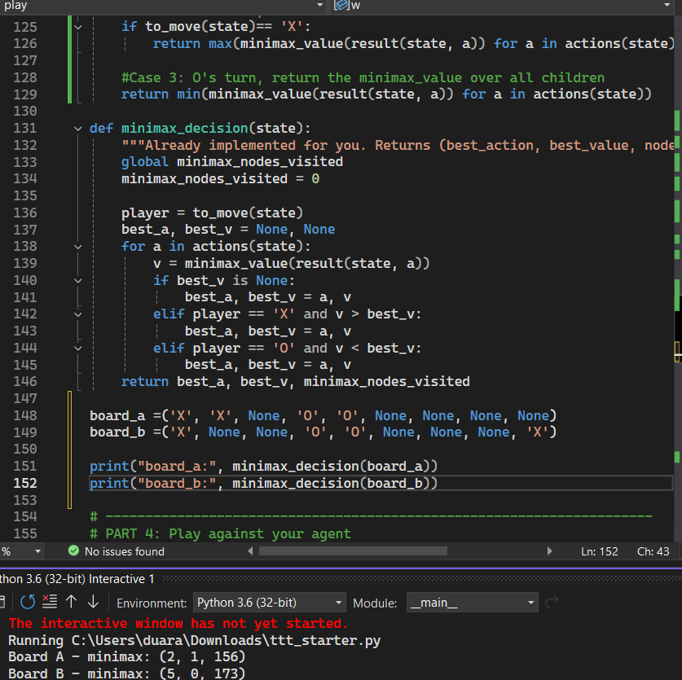

Question 3.3: Run It on the Empty Board (4 Points)
Run minimax_decision on the empty board (all None). Report the move chosen, the value, and the total number of nodes visited (minimax_nodes_visited). It may take a second or two to finish — that pause is the entire game tree of tic-tac-toe being walked one node at a time.

Question 3.4: Reflection — Stacks, DFS, and Minimax (8 Points)
Every call to minimax_value(state) is a stack frame: Python pushes a new frame when the function calls itself on a child, and that frame doesn't return (pop) until every one of its own children has been fully explored. In 3–5 sentences: why does this make minimax's traversal identical in spirit to the stack-based depth-first search from Lecture 3 and Assignment 2, and why does minimax only ever need to remember a single path through the tree at a time — O(bm) memory — rather than an entire level of it, the way breadth-first search would? Minimax is more like a stack because it first expands all the nodes of a parent tree before moving onto to the next parent. It follows the lifo method so the parent frame waits underneath the stack as the child tree is first explored until it reaches a leaf and then is returned back to the parent similar to minimax. BFS explores each level before moving onto the next and thus needs to remember each level and their sub levels, unlike minimax which only need to remember a branch of a tree. (parent +child nodes)

Part 4: Playing Your Agent (12 Points)
A play() function is provided for you (also in the starter file) — it puts you in the game as O against your own minimax agent, which plays X and always moves first. The agent's first move will take a second or two to compute, since it's walking the entire game tree — that's the same pause you measured in Question 3.3.
def play():
state = INITIAL_STATE
print("You are O. The agent is X and moves first.")
while not is_terminal(state):
if to_move(state) == 'X':
a, v, nodes = minimax_decision(state)
print(f"Agent (X) plays {a} [searched {nodes} nodes]")
state = result(state, a)
else:
print_board(state)
legal = actions(state)
move = None
while move not in legal:
try:
move = int(input(f"Your move {legal}: "))
except ValueError:
pass
state = result(state, move)
print_board(state)
w = winner(state)
print("Result: draw." if w is None else f"Result: {w} wins.")

Question 4.1: Play Three Games (12 Points)
Call play() and play three full games against your agent. Report (provide screenshot) the outcome of each game (win / lose / draw for you).
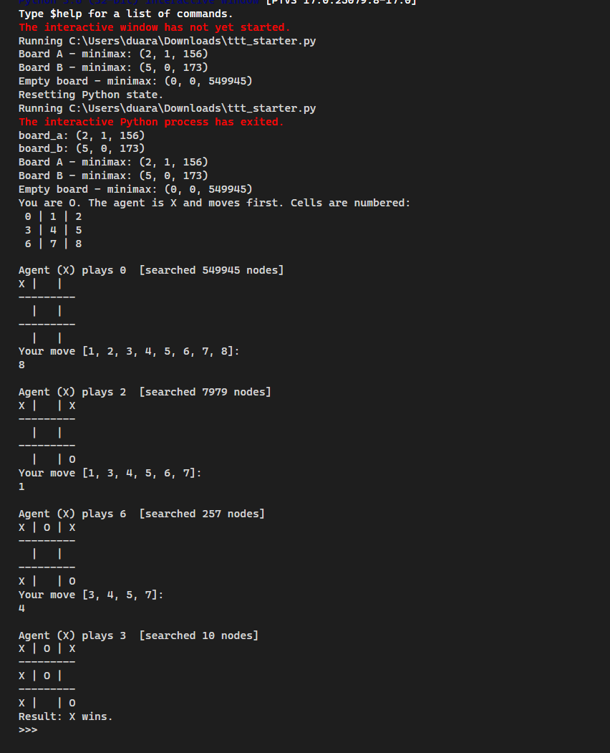
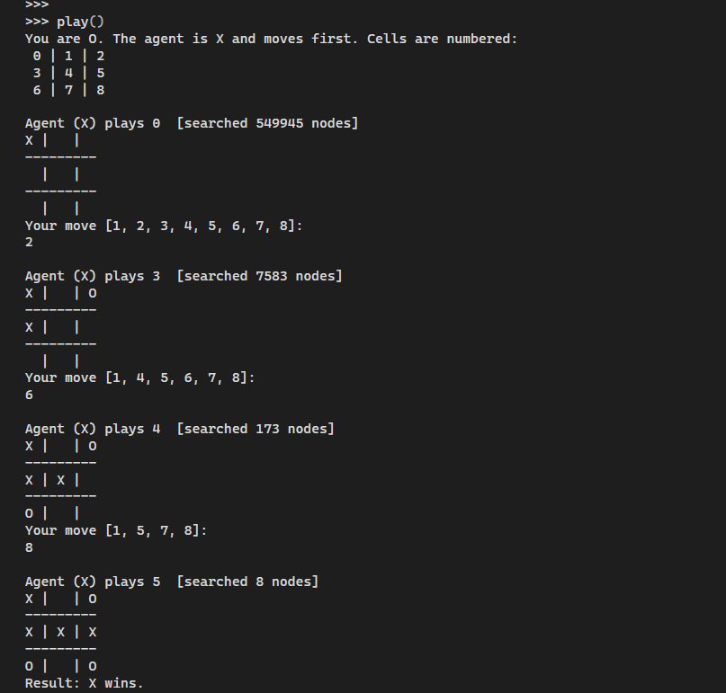
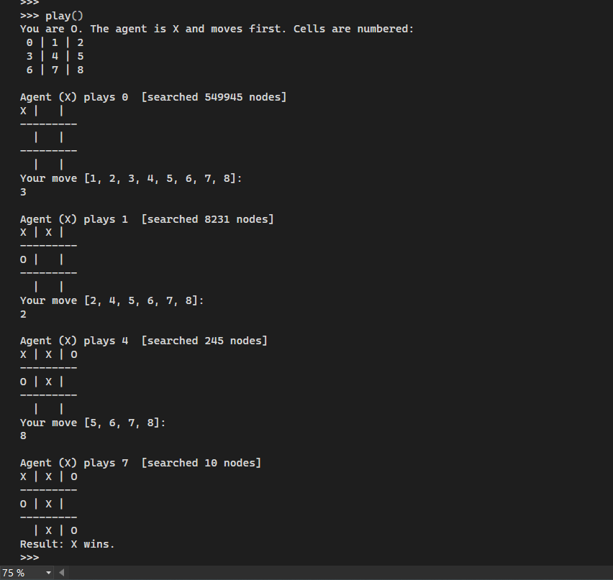

Submission
Submit your completed ttt_starter.py (renamed to include your name) along with a short PDF or Word write-up containing your answers to all questions, including the reported outputs, node counts, and reflections. Submit both files to Blackboard.
The total points for this assignment is 80. The penalty for late submission is that the assignment will not be graded.
You will need to answer all the parts in this report. However, only one part (chosen before grading, but the same for all students) will be graded by the TA, and a score is posted.
Please feel free to use this doc as your template for the assignment.

